Final Year Project Full Procedure

**Number Plate Recognition:** [https://learnopencv.com/automatic-license-plate-recognition-using-deep-learning/#:~:text=Automatic%20License%20Plate%20Recognition%20(ALPR)%20or%20ANPR%20is%20the%20technology,in%20a%20matter%20of%20milliseconds.](Final%20Year%20Project%20Full%20Procedure.docx)

All the techniques are applied in above website.

YOLOv4

License plate Dataset

PaddleOCR

Darknet Framework

ALPR computer vision application and ANPR

Dataset: [Final Year Project Full Procedure.docx](Final%20Year%20Project%20Full%20Procedure.docx)

Why ALPR:

1. Work on blurry images
2. Work when plate is at angle
3. Work in dark environment
4. Works when vehicle is driving fast
5. Work on Low-Res images
6. Works on plate with icons
7. Works with multiple vehicles
8. Works on plates with two rows

Note: **RESULTS:** Plate Recognizer ALPR results were correct up to 30 pixels of the plate width.  It failed at 28 pixels of plate width.

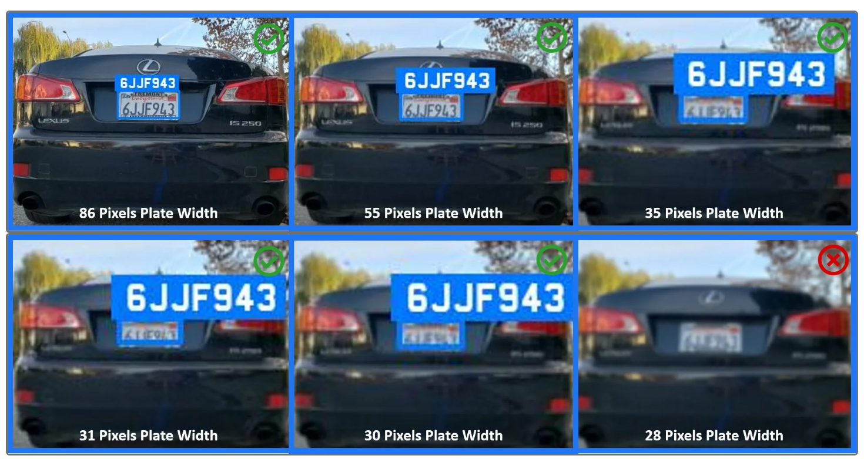

YouTube Video: [Final Year Project Full Procedure.docx](Final%20Year%20Project%20Full%20Procedure.docx)

GitHub Darknet implementation: [Final Year Project Full Procedure.docx](Final%20Year%20Project%20Full%20Procedure.docx)

**YouTube Resources:** [**https://www.youtube.com/watch?v=WLC4Fa4Ke3E&ab_channel=DigitalDaru**](https://www.youtube.com/watch?v=WLC4Fa4Ke3E&ab_channel=DigitalDaru)

**Resource**[**: https://www.youtube.com/watch?v=fyJB1t0o0ms&ab_channel=Computervisionengineer**](:%20https:/www.youtube.com/watch?v=fyJB1t0o0ms&ab_channel=Computervisionengineer)

**GitHub:** [**https://github.com/SuruchiParashar/vehicle-number-plate-detection/blob/master/Number%20Plate%20Images.zip**](https://github.com/SuruchiParashar/vehicle-number-plate-detection/blob/master/Number%20Plate%20Images.zip)

**Number Plate Recognition using YOLO8:** [**https://github.com/computervisioneng/automatic-number-plate-recognition-python-yolov8**](https://github.com/computervisioneng/automatic-number-plate-recognition-python-yolov8)